Process Synchronization
Process synchronization is a way to make sure that multiple processes / programs running on a computer can work together without causing problems. When many processes share resources like memory, printers, or files, they need to take turns or coordinate so that everything runs smoothly.
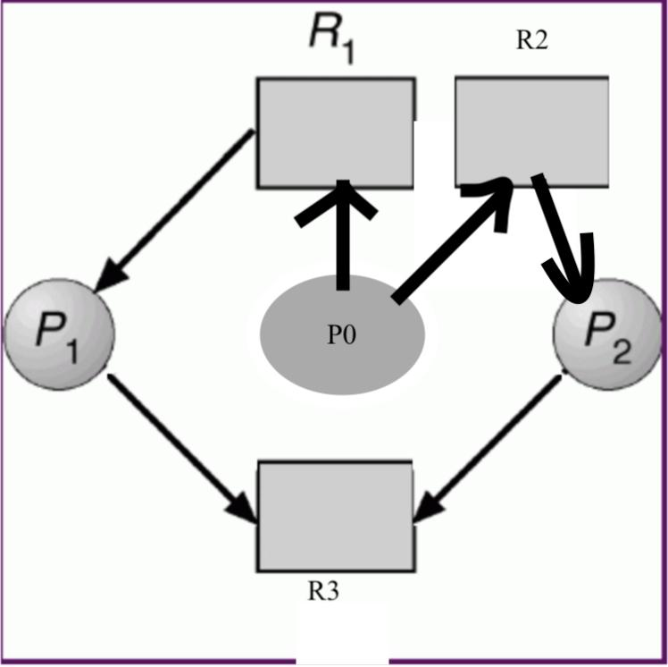
Processes trying to access the same resource at the same time.
Why Process Synchronization is Important
Without synchronization, processes may interfere with each other. This can cause:
- Data inconsistency: inaccurate or mixed-up information.
- Deadlock: Processes waiting too long for each other.
Race conditions: When the outcome depends on which process finishes first.
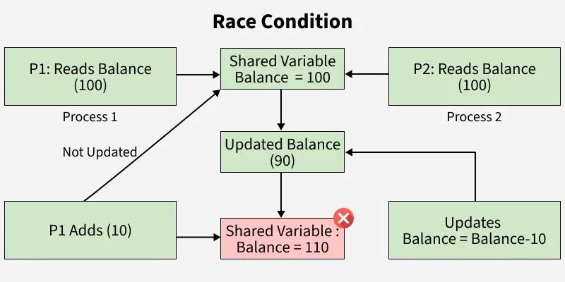
Race condition example showing two processes updating the same variable incorrectly.
Critical Section Problem
The critical section is a part of a program where a process accesses shared resources. Only one process should be in its critical section at a time.
Three main requirements:
- Mutual Exclusion:Only one process in the critical section at a time.
- Progress: If no process is in the critical section, one waiting process should get access.
- Bounded Waiting: Every process should get a turn eventually
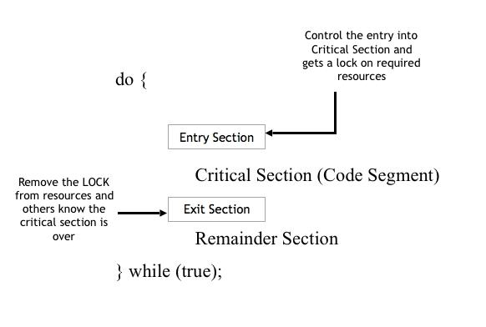

Synchronization Tools / Mechanisms
1. Semaphores
A semaphore is a variable used to control access to shared resources. It can signal whether a resource is available.
2. Mutex (Mutual Exclusion)
A mutex is like a lock. A process locks it when entering the critical section and unlocks it when done.
3. Monitors
Monitors are high-level tools that manage access to shared resources automatically.
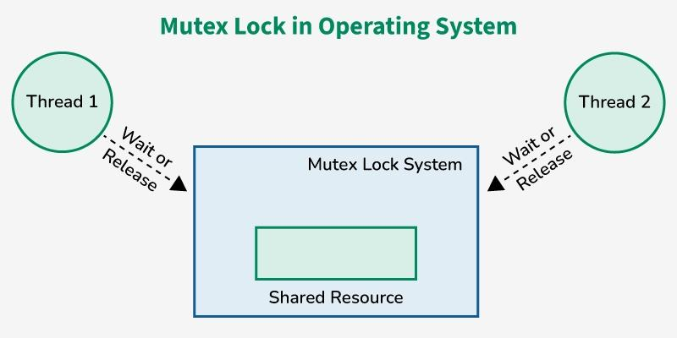
Classical Synchronization Problems

Producer-Consumer Problem
The producer creates data and the consumer uses it. Synchronization ensures the producer does not overflow the buffer and the consumer does not read empty data.
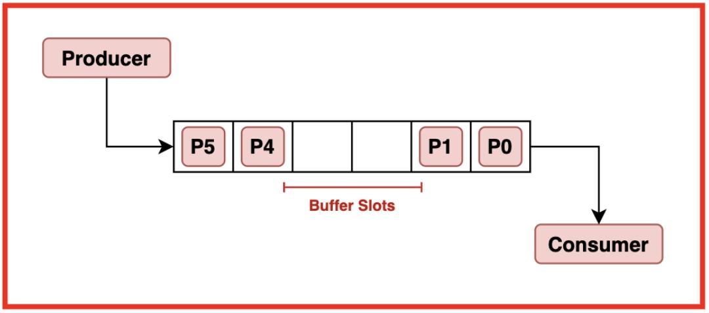

Dining Philosophers Problem
Philosophers sit at a table with forks. They need two forks to eat. This problem shows deadlock and synchronization challenges.

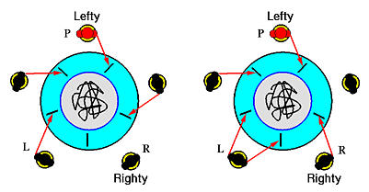

Summary
Process synchronization is essential to make sure that multiple processes run smoothly, avoid conflicts, and ensure data safety. By using tools like semaphores, mutexes, and monitors,we can coordinate processes effectively.

